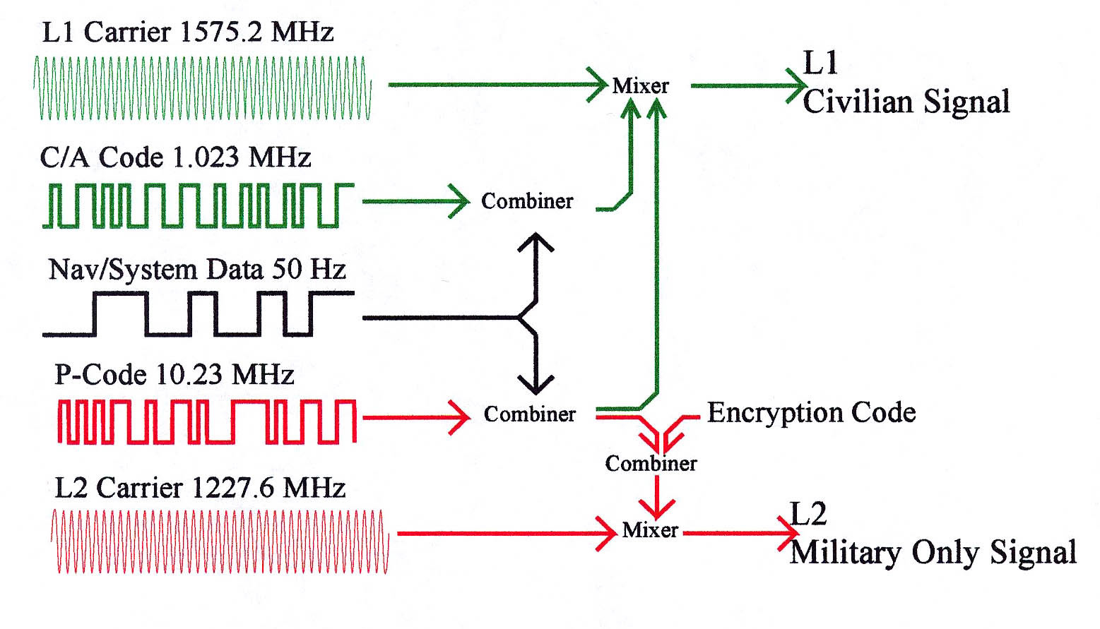
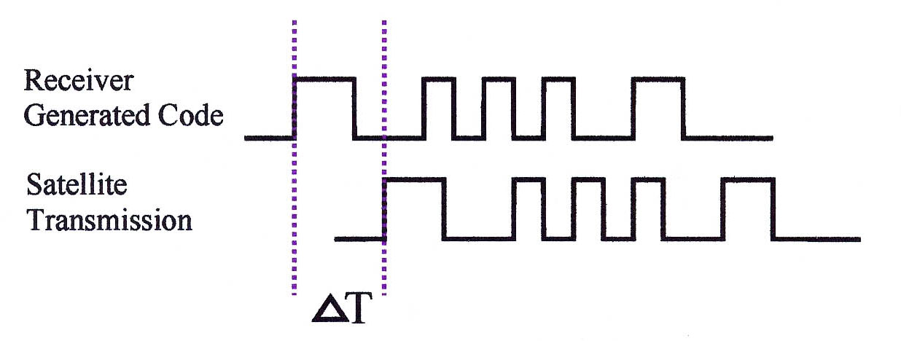
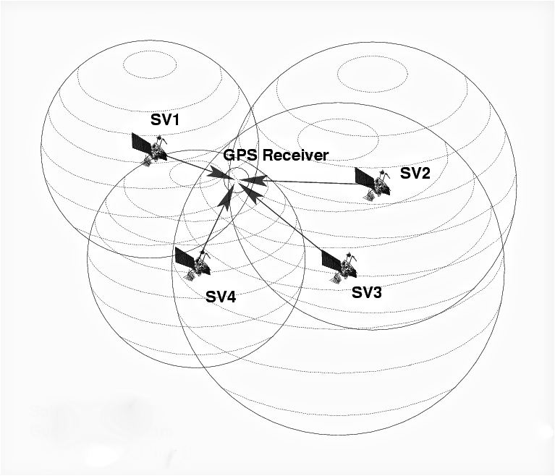

THE PRESENT AND FUTURE RISK OF GLOBAL POSITIONING SYSTEM (GPS) SPOOFING

Alexander J. Aavang* and Roger G. Johnston**

Vulnerability Assessment Team
Nuclear Engineering Division
Argonne National Laboratory
Argonne, IL 60439-48490

* Current Institution: Elgin Community College, 1700 Spartan Dr, Elgin, IL 60123
** Corresponding author: Roger Johnston, rogerj@anl.gov, 630-252-6168

ABSTRACT:
In a society increasingly dependent on the Global Positioning System (GPS)—or someday perhaps a foreign variant—to get from point A to point B or to know the time precisely, we must recognize the risks associated with not having secure navigation or time signals. The main problem with satellite-based navigation systems (such as the current American GPS, the European Galileo, and the Russian GLONASS) is that civilian signals (those signals used by public and most government agencies) lack any form of “anti-spoofing” countermeasures. This leaves commercial GPS receivers vulnerable to signal blocking, jamming, and “spoofing” (the sending of fake signals that can cause the receiver to report false time and/or position information). In this current project, discussion with the development teams of various navigation systems, together with study of the public material on signal characteristics, provided a firm understanding of both current and planned navigational systems and the aspects of their security. After researching this topic, we have come to the conclusion that there appear to be no plans for increasing the security of civilian signals. If spoofing occurs in critical systems, such as utility and telecommunication grids, computer networks, financial systems, security management, cargo security (including nuclear shipments), or aviation, the results could be catastrophic. As the world prepares for the transition to upcoming next-generation navigational systems (including the FAA’s Next-Generation Air Transportation System), careful thought should be given to the security and safety implications of GPS spoofing.

INTRODUCTION
Since reaching full operational capacity in 1995[1], the American Global Positioning System (GPS) has grown to be a major commodity in today’s market. Outgrowing its original military use, GPS is now being used by government, businesses, and private citizens for both mundane and critical applications. Some of these applications include public transportation; law enforcement; cargo tracking; aviation guidance; monitoring of pets, children, and convicted criminals; and emergency services coordination, as well as providing critical time synchronization signals for utility, telecommunications, and computer networks and grids. With each of these applications, GPS has become a crucial component, heavily relied upon to guarantee the success of the system. People are often unaware of the amount of infrastructure that relies on GPS to function correctly. In the future, with the development of the NextGen Air Transportation System, society may well be placing its well being evenly more substantially into the hands of GPS.

For GPS applications, there are three major security issues: signal blocking, jamming, or spoofing. Signal blocking can often be accomplished by breaking off the GPS antenna, surrounding the GPS receiver with metal, or placing it beneath bridges or tree canopies that can hide the GPS signals from space. Signal jamming involves generating a noisy signal at the same frequency, but with a higher signal strength than the original GPS signals. Given that the GPS signal strength at the Earth’s surface is only about -160dBw or 1x10⁻¹⁶ Watts (roughly equivalent to viewing a 25-Watt light bulb from a distance of 10,000 miles), it is not difficult to overpower.

While blocking or jamming is easy to accomplish, it is also very easy to detect. As soon as the user loses satellite reception, he or she knows something is wrong. Spoofing, a more sophisticated attack, leaves the user unaware that an attack is occurring at all. By sending fake, but correctly formatted GPS signals, an attacker can fool the receiver into thinking that these stronger signals are valid GPS satellite signals. This results in the receiver reporting erroneous time and/or position information.

In previous demonstrations [5,8] at Los Alamos from 2002-2006 by the Vulnerability Assessment Team (now at Argonne National Laboratory) various commercial GPS receivers could be fooled (from a distance of over a mile) into thinking that they were traveling more than 600 miles per hour, when in fact they were stationary, or that they were in the wrong region of the country. Remote spoofing of a commercial GPS time synchronization unit was also demonstrated. [5,8] Others have also demonstrated GPS spoofing [7].

HOW GPS WORKS
The GPS system uses a network (or, “constellation”) of 27 satellites, which constantly orbit the Earth in six separate orbits, arranged to ensure that, at any given moment, there are six GPS satellites visible at any point on Earth. Of these 27 satellites, 24 of them are active while the other three are on standby [1]. Using trilateration, a method to determine the intersection of multiple spheres, a GPS receiver can calculate it’s 3-D position and velocity, while receiving time updates from the GPS satellite onboard atomic clock. Calculated positions are typically accurate to within 3-5 m (10-16 ft) on average.[2]

The original GPS system broadcasted two signals, an unencrypted civilian signal and an encrypted military signal. For the purposes of this paper, only the civilian signal will be considered because most GPS users (both civilian and federal) can only use the civilian signals. The civilian code consists of two data signals and a carrier wave, shown in Figure 1. The signal labeled “C/A code” is the identification code unique to each satellite. The Nav/System data provides a GPS receiver with information on the satellite orbits and positions, precise timing information (provided by atomic clocks onboard the satellites), as well as information on the status of the satellites. The Nav/System data and the C/A code are then combined and modulated within a carrier wave. For the L1 civilian signal, the carrier wave’s frequency is 1575.2 MHz.

Figure 1 - Civilian GPS Signal Format.

In order to accurately determine its 3-D location, the GPS receiver must lock onto at least 4 satellites. When the receiver locks onto a GPS signal, it indentifies the sending satellite’s identity by examining C/A code. The receiver then generates a corresponding C/A, which matches that of the satellite. By comparing the internally generated code to the repeated code from the satellite, the receiver is able to calculate the distance between it and the satellite using Distance = ΔT x Speed of Light (see Figure 2).

Figure 2 - GPS Timing Diagram.

Once the distance to the satellite has been found, the position of the receiver can be found on the surface of a sphere with a radius of distance between the receiver and the satellite. Now, an exact position cannot be determined from a single satellite. By repeating the previous steps with three other satellites, however, the intersection of the corresponding spheres will be the location of the GPS receiver. See figure 3.

Figure 3 - Calculating Receiver Position.

But what happens when the surfaces of the spheres don’t meet at a single point? This is caused by timing errors within the receiver’s clock due to the fact that the receiver does not itself have an internal atomic clock provide extremely precise time information. To deal with this problem, the receiver interpolates the overlapping area between the spheres and finds the center. This provides the receiver with both its position (in X, Y, Z coordinates which is later converted into Longitude, Latitude and Altitude) and the receiver clock error. As the number of visible satellites increases, the overlapping area decreases, and the position accuracy improves.

With the new GPSII –the modern version of GPS– satellites now in orbit, starting with the first GPSII satellite launch back in 2005 and the goal for a complete constellation of 24 satellites by 2014 [10], users will have as access three civilian signals, one encrypted and two unencrypted [3], as well as the original two encrypted military signals. These signals will become the backbone of the new GPSII. The two unencrypted civilian signals, designated L1 and L5, will be openly available to the public. The third civilian signal, L2, will consist of a signal specifically tailored for commercial applications, resulting in higher accuracy and acquisition speed. [10] As with the original GPS signals, the two new civilian signals that most people will rely on will remain unencrypted and unauthenticated, leaving them still open to “spoofing”, i.e., the malicious sending of false position and/or timing information.

SECURITY VULNERABILITIES
Due to the unsecured nature of today’s civilian GPS signals, it is disconcerting how many critical applications rely on GPS. Whether it is the control of an electrical grid, or plotting an accurate flight path, GPS accuracy is depended upon to provide correct and high-precision data Listed below are some of the applications of GPS today and the potential risks associated with GPS spoofing.

Electrical Grid Monitoring: According to the Bonneville Power Authority [9], there are plans for a GPS-monitored power grid. This grid would be responsible for time-stamping (with microsecond accuracy) the voltage and current measurements from a power grid spanning from the west coast to the Rocky Mountains.
Risks: Timing de-synchronization as a result of GPS spoofing or jamming could cause major power fluctuations in the grid, potentially leading to catastrophic failure of the system. [4] Even without such a fully GPS-monitored power grid, current utility grids that use GPS for time synchronization may still be vulnerable to GPS spoofing

Fleet Tracking: Many trucking companies now use GPS to track individual vehicles in their fleets. These systems employ GPS receivers that relay their position, velocity, and time data back to the fleet headquarters. This information is used both for logistics planning, but also to try to recover stolen cargo.
Risks: Spoofed GPS signals could cause the receiver to report false position data back to the fleet headquarters. This would allow car thieves to give the illusion that the vehicle is on route when in fact it has been hijacked and is being redirected elsewhere.

Nuclear Waste Tracking: Businesses such as Zia Systems and The Washington Group helped develop and currently use GPS units to track inventory, including nuclear waste, while in transit. [11]
Risks: If a truck carrying nuclear waste was the target of a spoofing or jamming attack, it would be possible to steal nuclear material and either fake a transmission signal or simply disable the transmitter. In either case, nuclear material is now in the hands of wrongdoers. This could lead to any number of disastrous events including the use of the material in dirty bombs and Improvised Nuclear Devices (INDs).

Aviation: With the current U.S. aviation radar system rapidly becoming a financial burden on the American government, the Federal Aviation Administration (FAA) is planning to replace the outmoded radar network with GPS stations. This system, dubbed the “Next Generation Air Transportation System” (or NextGen), would rely on receiving positional data broadcasted from GPS satellites and from transponders located within each plane to calculate and maintain “aerial roadways” and allow for optimized flight paths and airplane spacing.
Risks: GPS spoofing could mislead aircraft pilots as to their true location and/or elevation, resulting in potential hazards to the plane, passengers, and people and assets on the ground, especially during inclement weather. Further, GPS spoofing by a passenger aboard an aircraft could cause the plane to falsely report its position, thereby assisting in hijacking by presenting an opportunity to make unreported course changes. A pilot could also disable the onboard transponder, rendering the plane invisible to listening receivers. [6]

Rail Transportation: Rail systems worldwide use GPS in conjunction with ground-based sensors to better coordinate trains and improve safety, security, and rail efficiency. Using GPS, rail controllers can ascertain the precise positions of trains which helps prevent collisions and speeds up track management.
Risks: If the rail system’s implementation of GPS technology entirely eclipses the reliance on local rail sensors, GPS spoofing could cause massive delays and collisions due to the lack of reliable time and position information.

Emergency Response Coordination: 911 dispatchers use GPS signals to pinpoint distress calls and guide emergency responders precisely to the needed location. The GPS data is usually broadcasted using either an individual’s cellular phone or from his or her vehicle.
Risks: Given that a jammer operating at one watt of power can jam GPS receiver over an area of 100 kilometers [13], it would not be hard for terrorists to trigger a disaster and then jam the area to cause further mayhem. If this would occur, the death toll would increase do the emergency responders not being able to locate disaster victims.

A Closer Look at NextGen
The Next Generation Air Transportation System represents the Federal Aviation Administration’s (FAA) planned expansion of the existing national air transportation system. By incorporating GPS and other satellite-based navigation systems, the FAA hopes to move away from the outmoded radar system currently in use. At the heart of NextGen is the Automatic Dependent System Broadcast (ADS-B). This utilizes GPS signals to report a plane’s position to both the ground controller and other aircraft using transponders within each aircraft. The transponders receive GPS signals and, just like the GPS receivers used in cars, use them to calculate the planes precise location in the sky. This information is then broadcasted to the ground controller, other aircraft, and any other receiver listening on that frequency.

Darryl H. Phillips, an aviation engineer and founder of AirSport Corporation, detailed multiple scenarios in which the ADS-B system could be used and abused to commit a wide variety of crimes. [6] The main problem with ADS-B is that, for the first time in aviation history, the information “Who I am” is united with “This is where I am” on a single open frequency. [6] This gives anyone with a receiver capable of listening on the 1090 MHz frequency the ability to discern the identity and location of any plane in the immediate area[6], and to potentially spoof that information.

GLONASS, Galileo, and COMPASS
Other countries are seeking their own version of a Global Navigation Satellite System (GNSS). There are 3 major efforts in this direction: , the Russian GLONASS, the European Galileo, and the Chinese COMPASS. We contacted the development teams of each of these systems, asking them to comment on what security measures they have in place or planned to guard against spoofing and other attacks. Enrico Introini, of the Galileo security division stated that, “Galileo will not offer more on authentication and security than GPS does.” G. Penin, a MCC IAC Senior Specialist working with GLONASS, offered no specifics on what safeguards GLONASS employs, but merely stated that, “The problem of signal authentication is really very important for both GPS and GLONASS systems, especially in transport applications.” The development team for the Chinese COMPASS has, to this date, not responded to our inquiries.

Conclusion
We are currently unaware of any nefarious examples of GPS spoofing or jamming of civilian GPS signals. (It is not clear, however, that GPS spoofing—being surreptitious—would be recognized as such, or that its victims would necessarily publicize spoofing incidents.) Despite the lack of current GPS jamming or spoofing incidents, it is imperative that the security risks associated with its use be understood. . Going forward into a future where GPS is relied on even more than it is today for a wide variety of critical applications, having open and unencrypted GPS signals that are vulnerable to malicious attacks could lead to catastrophic consequences. As a precaution against this, it would seem prudent to keep a backup timing system available to step-in if the GPS systems fail or become compromised. For example, when dealing with power grids, one should have a Network Time Protocol (NTP) Server capable of maintaining grid timings should the GPS atomic clock signals become unavailable. Having a contingency plan for dealing with GPS failure could mean the difference between a minor inconvenience and a major loss of capital or life. The Vulnerability Assessment Team and researchers at Cornell University has also proposed inexpensive techniques for detecting relatively unsophisticated GPS spoofing. [8,12]

Acknowledgements and Disclaimers

The views expressed in this paper are those of the authors and should not necessarily be ascribed to Argonne National Laboratory or the United States Department of Energy. This work was performed under the auspices of the United States Department of Energy (DOE) under contract DE-AC02-06CH11357, and supported in part by the Argonne Summer 2010 Student Program. We would also like to thank the Argonne Library for it assistance in acquiring crucial documents related to this research.

References
- US Coast Guard, “GPS - Frequently Asked Questions”, 2003, http://www.navcen.uscg.gov/faq/gpsfaq.htm.
- “GPS Explained: Position Accuracy”, 2009, http://www.kowoma.de/en/gps/accuracy.htm
- Office of Space Commercialization, “GPS Modernization”, 2010, http://www.space.commerce.gov/gps/modernization.shtml
- Bland, Eric, “GPS 'Spoofing' Could Threaten National Security”, Discovery Channel, 2008,
http://dsc.discovery.com/news/2008/10/02/gps-spoofing.html
- J. Warner and R. Johnston, “A Simple Demonstration that the Global Positioning System (GPS) is Vulnerable to Spoofing”, Journal of Security Administration 25, 19 (2002).
6. Phillips, Darryl H. "ADS-B ... Terrorist's Dream, Security's Nightmare." AirSport Avionics - Altitude Alerters/Transponder Monitors. July 2000.
http://www.airsport-corp.com/adsb2.htm
7. Argonne Vulnerability Assessment Team,
http://www.ne.anl.gov/capabilities/vat
8. JS Warner and RG Johnston, “GPS Spoofing Countermeasures”,
Homeland Security Journal, December 12, 2003,
http://www.homelandsecurity.org/bulletin/Dual%20Benefit/warner_gps_spoofing.html
9. Erickson, Dennis, and Carson Taylor. "Pacify the Power: GPS Harness for Large-area Electrical Grid | GPS World | Find Articles at BNET." Find Articles at BNET | News Articles, Magazine Back Issues & Reference Articles on All Topics. GPS World, Apr. 2005. Web. 28 July 2010. http://findarticles.com/p/articles/mi_m0BPW/is_4_16/ai_n13807803/
10. Louden, Doug. GLOBAL POSITIONING SYSTEM GLOBAL POSITIONING SYSTEM Status. Rep. USSLS/CGSIC, 27 May 2007. Web. 28 July 2010. http://www.navcen.uscg.gov/pdf/cgsicMeetings/International_Subcommittee/Geneva0528//03%20Geneva%20Louden.pdf
11. Roberts, Elaine M. "Equipment Theft Leads to Asset Tracking System." Springfield News-Sun. 29 May 2010. Web. 28 July 2010. http://www.springfieldnewssun.com/news/springfield-business-news/equipment-theft-leads-to-asset-tracking-system-735984.html.
12. Humphreys, Todd E., Paul M. Kinter Jr., Mark L. Psiaki, Brent Ledvina, and Brady O'Hanlon. Assessing the Spoofing Threat. GPS World. Cornell University, 1 Jan. 2009. Web. 28 July 2010. http://www.gpsworld.com/defense/security-surveillance/assessing-spoofing-threat-3171.
13. Ruley, John. "GPS Jamming." AVweb. 12 Feb. 2003. Web. 28 July 2010. http://www.avweb.com/news/avionics/182754-1.html.

